

# Test Automation

**Experiment 1 + 2**

**Submitted by : Submitted to :**

**Rahul Gusain**   **Mr. Alind A**

**AIM: Install conda and scrapy in your system and attach the screenshot of newly created environment in a terminal with scrapy installed**

**Step 1**: Install anaconda conda

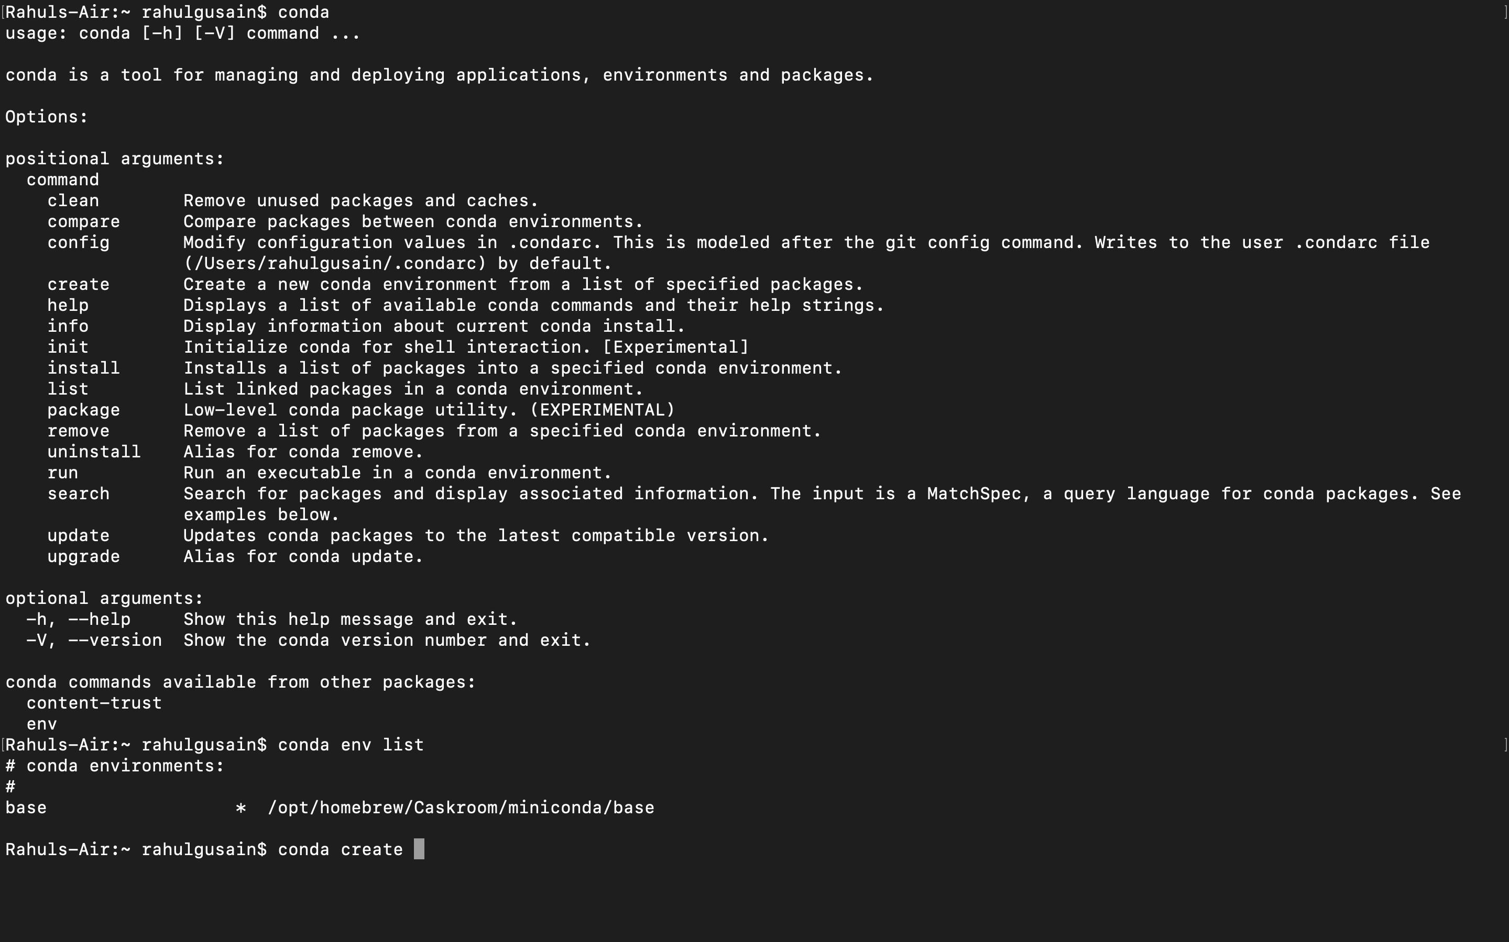

**Step 2**: Create and activate new environment

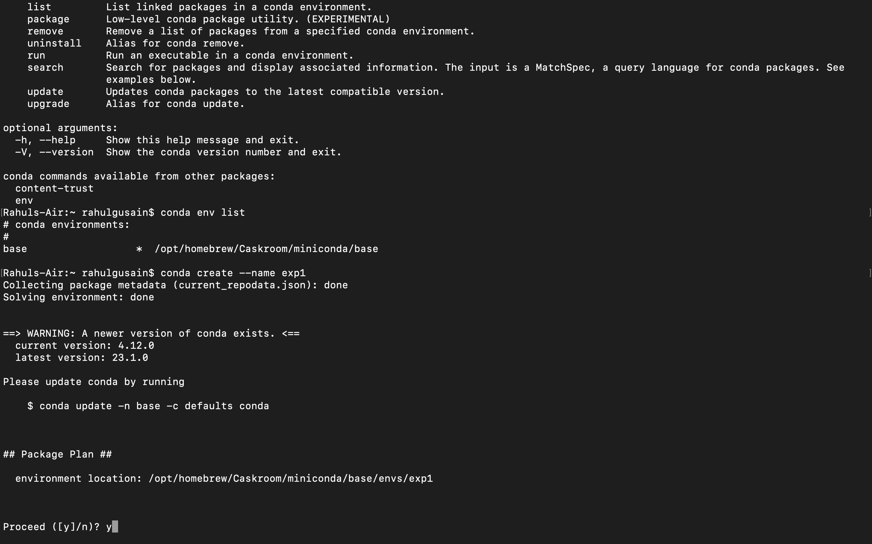

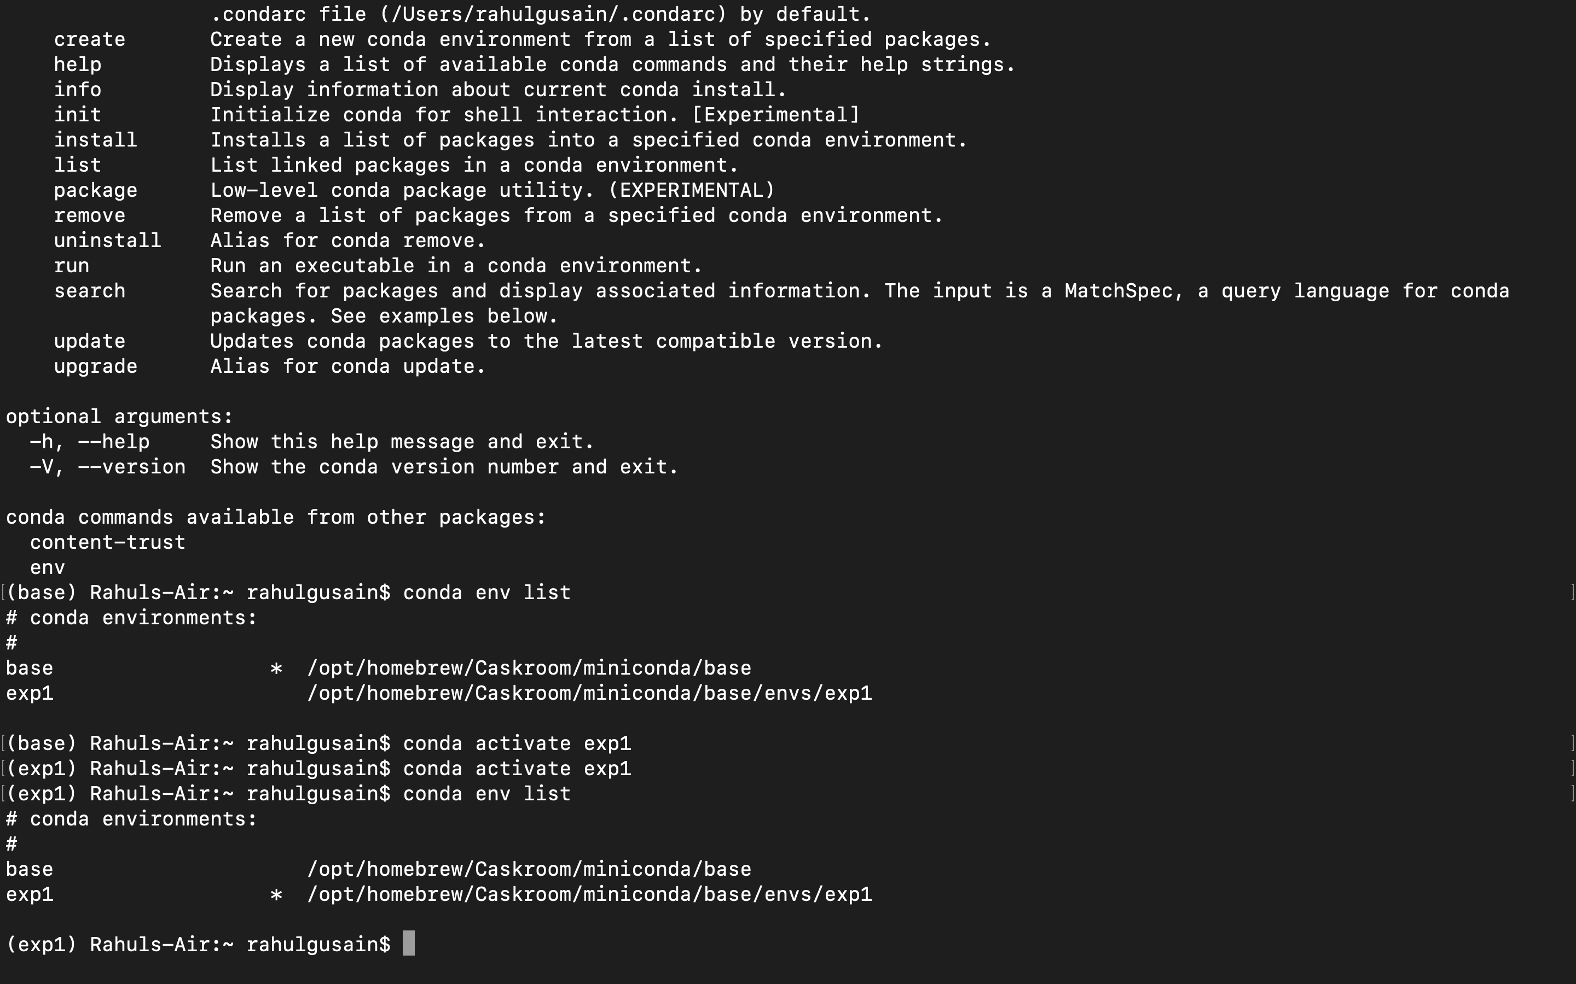

**Step 3**: Install scrapy in it

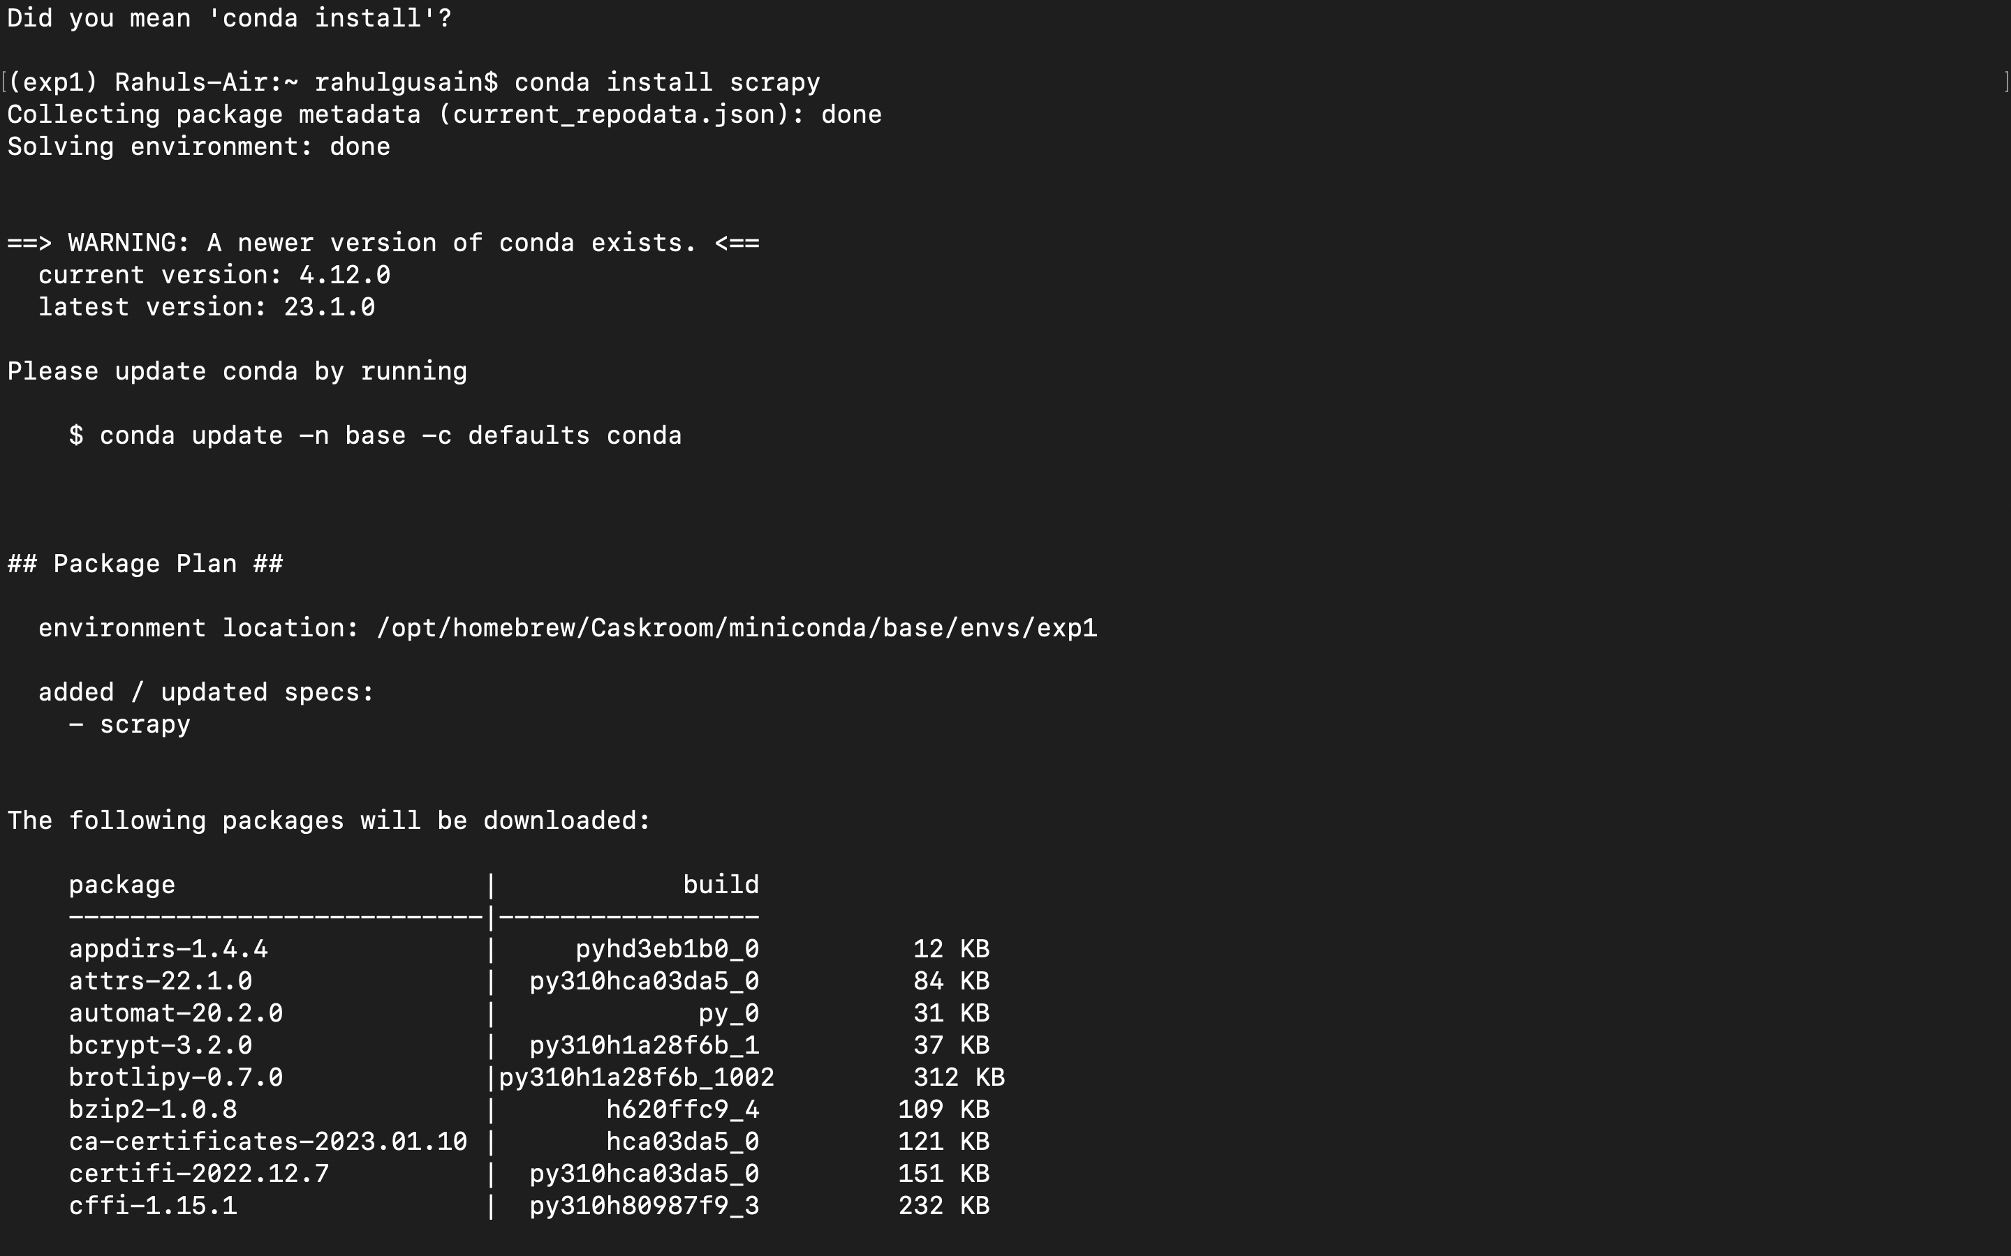

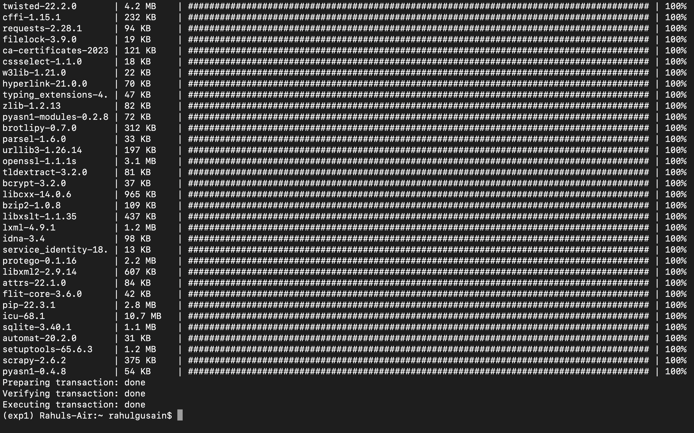

**Step 4**: Get list of environments



**Step 5** : Can install selenium in it

